Human Resources: UNUM Employee Add + Terminate

**Objective/Purpose/ Why:** All full-time employees are eligible for Life/AD&D, STD, LTD benefits, on their first day of hire, or transition from part-time to full-time.

**Subject Matter Expert:**

* All forms can be acquired from UNUM.com or from an ATG HR team member. Contact HR Director or HR Generalist(s).

**Process:**

1. Enrollment form

* Acquire completed form from employee. Current benefits as of 3/26/2020; life coverage up to 1x annual salary, maximum of 50K, 10K coverage for spouse, 5K coverage for children over 6 months.

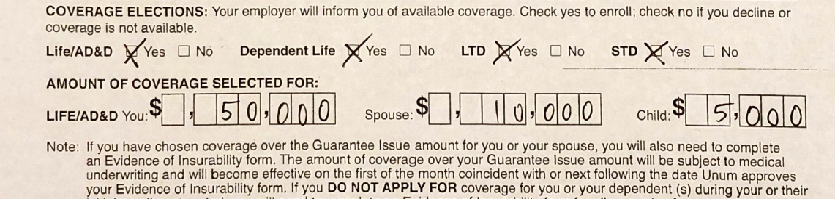

2. Log into Unum.com

* Plan Administrator (HR Director) will need to request access for you to receive access to your own username and password.

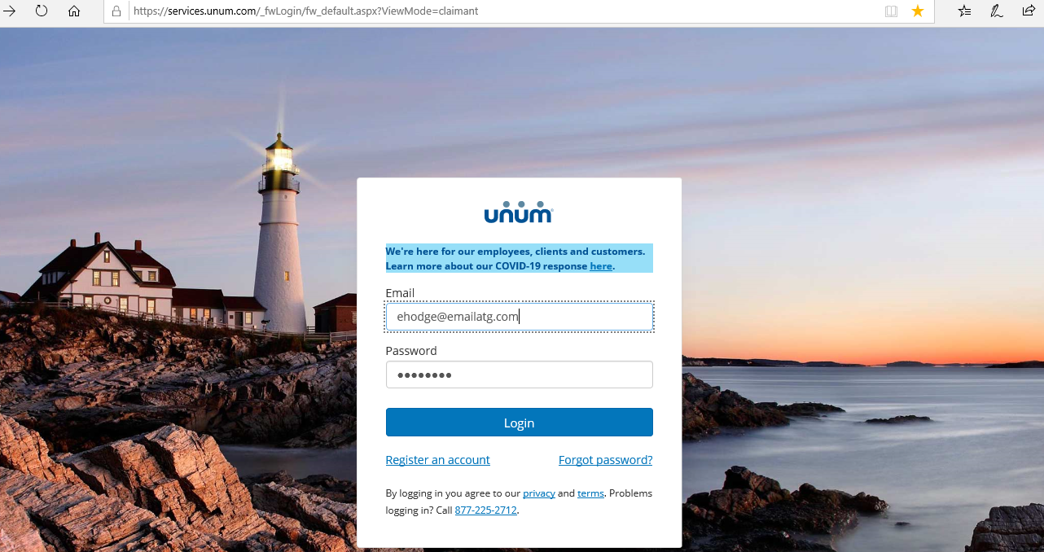

3. Add employee:

* Upon receiving completed enrollment form, proceed to login to Unum.com
* From the "Billing" drop-down, you must select "Employee Adds”.

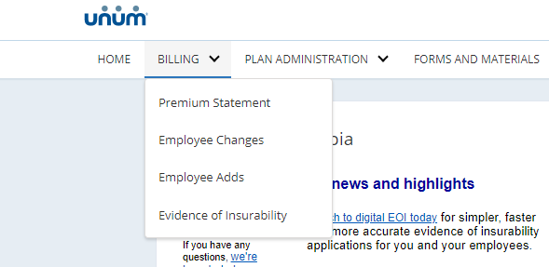

4. Select Billing Number

* 0297651-001 is the company paid plan.
* 0404703-001 is additional coverage, employee paid at group rate. (additional enrollment forms required)

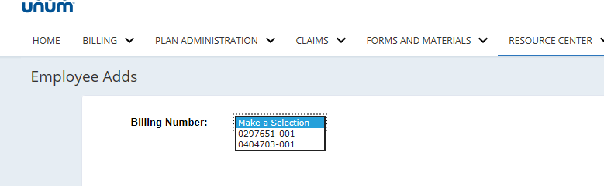

5. Enter basic information to build employee profile.

* Use the information provided by employee on the enrollment form. The example below is applicable to most ATG staff.
* Complete and click “Continue”

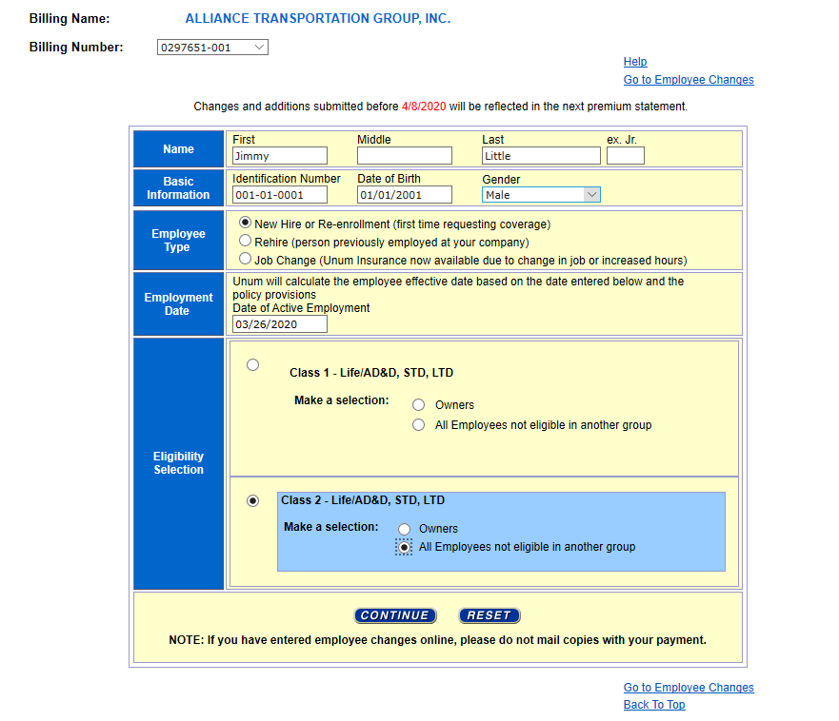

6. Complete Dependent Info and Earnings

* Select dependent eligibility. Mark “Yes” if the employee has a spouse and/or children. “No” if neither.
* Enter annual salary and click “SUBMIT”.
* Document enrollment. Select “View History”, print the confirmation page to PDF and save to the benefits folder in their personnel file. (ie: Little_J UNUM Enroll.)

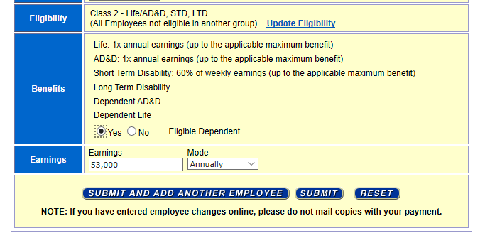

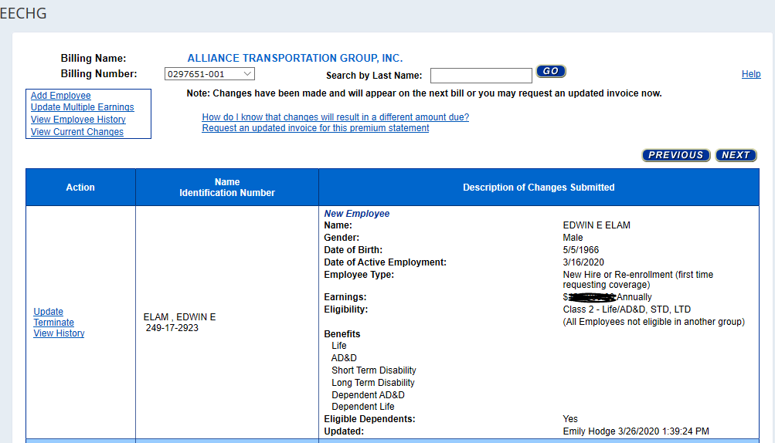

UNUM: Employee Term

1. Login using UNUM Username and Password (same instructions as above)

2. Employee Change

* Scroll to the bottom of the home page and find the “Employees” section.
* Click on “Terminate Employees”

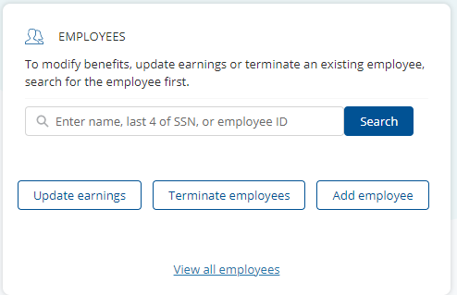

3. Select Termed Employee

* Confirm correct Billing # (IF termed employee has both Company-paid as well as Additional life insurance, you will need to terminate from both plans).
* Find the Employee you are Terminating and hit the drop down. In most cases you will click “Termination of Employment”, choose other options if necessary.
* Enter their Last Day of Employment. And Click “Next” at the bottom of the page.

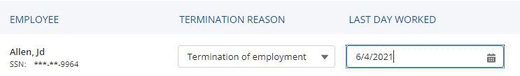

Last Name, First Name

3. Review & Submit

* The employee(s) you are terminating should be displayed. Make sure that you have the right first and last name.
* Click “Submit” . A copy of the employees UNUM Term should be saved to their benefits folder in their personnel file.

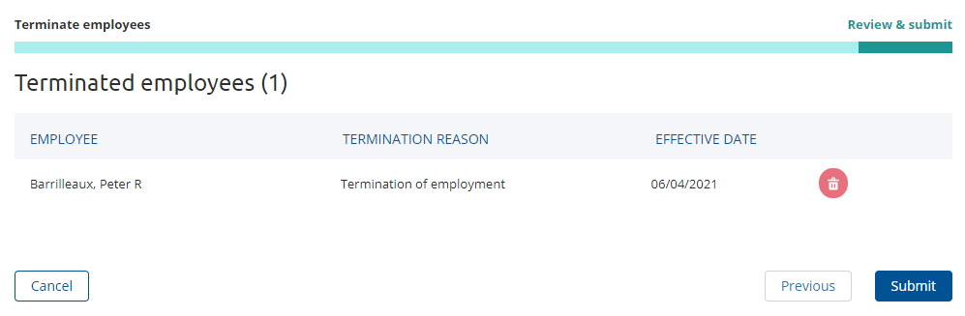

Last name, First name

**Outcome:**

* **Enrollment:** Employee obtains coverage. The employee’s personal information and eligibility date is entered into the providers online web portal. Employee is made effective and obtains Life/AD&D, STD, LTD benefits.
* **Termination:** The employee has lost eligibility for Life/AD&D, STD, LTD benefits, and coverage will end on the last day of the month of the employees qualifying event.

**Resources:**

* A copy of the employees Enrollment form should be saved to their benefits folder in their personnel file.
* A copy of the employees UNUM Term should be saved to their benefits folder in their personnel file.

**Definitions:**

* **UNUM:** Life/AD&D STD, LTD benefits for full time employees
* **AD&D:** Accidental Death and Dismemberment
* **STD:** Short Term Disability
* **LTD:** Long Term Disability
* **Dependents:** Spouse, Children. etc.
* **Termination:** Cancelation of benefit.
* **Termination Date:** Date of qualifying event.